VISVESVARAYA TECHNOLOGICAL UNIVERSITY
“JnanaSangama”, Belgaum -590014, Karnataka.

LAB REPORT
on
Artificial Intelligence (23CS5PCAIN)
Submitted by
Sinchana (1BM23CS329)
in partial fulfillment for the award of the degree of
BACHELOR OF ENGINEERING
in
COMPUTER SCIENCE AND ENGINEERING

B.M.S. COLLEGE OF ENGINEERING
(Autonomous Institution under VTU)
BENGALURU-560019
Aug 2025 to Dec 2025

B.M.S. College of Engineering,
Bull Temple Road, Bangalore 560019
(Affiliated To Visvesvaraya Technological University, Belgaum)
Department of Computer Science and Engineering

CERTIFICATE
This is to certify that the Lab work entitled “Artificial Intelligence (23CS5PCAIN)” carried out by Sinchana (1BM23CS329), who is bonafide student of B.M.S. College of Engineering. It is in partial fulfillment for the award of Bachelor of Engineering in Computer Science and Engineering of the Visvesvaraya Technological University, Belgaum. The Lab report has been approved as it satisfies the academic requirements in respect of an Artificial Intelligence (23CS5PCAIN) work prescribed for the said degree.

Sonika Sharma  Assistant Professor  Department of CSE, BMSCE | Dr. Kavitha Sooda  Professor & HOD  Department of CSE, BMSCE

Index
Sl.  No. | Date | Experiment Title | Page No.
1 | 30-9-2024 | Implement Tic –Tac –Toe Game  Implement vacuum cleaner agent
2 | 7-10-2024 | Implement 8 puzzle problems using Depth First Search (DFS)  Implement Iterative deepening search algorithm
3 | 14-10-2024 | Implement A* search algorithm
4 | 21-10-2024 | Implement Hill Climbing search algorithm to solve N-Queens problem
5 | 28-10-2024 | Simulated Annealing to Solve 8-Queens problem
6 | 11-11-2024 | Create a knowledge base using propositional logic and show that the given query entails the knowledge base or not.
7 | 2-12-2024 | Implement unification in first order logic
8 | 2-12-2024 | Create a knowledge base consisting of first order logic statements and prove the given query using forward reasoning.
9 | 16-12-2024 | Create a knowledge base consisting of first order logic statements and prove the given query using Resolution
10 | 16-12-2024 | Implement Alpha-Beta Pruning.

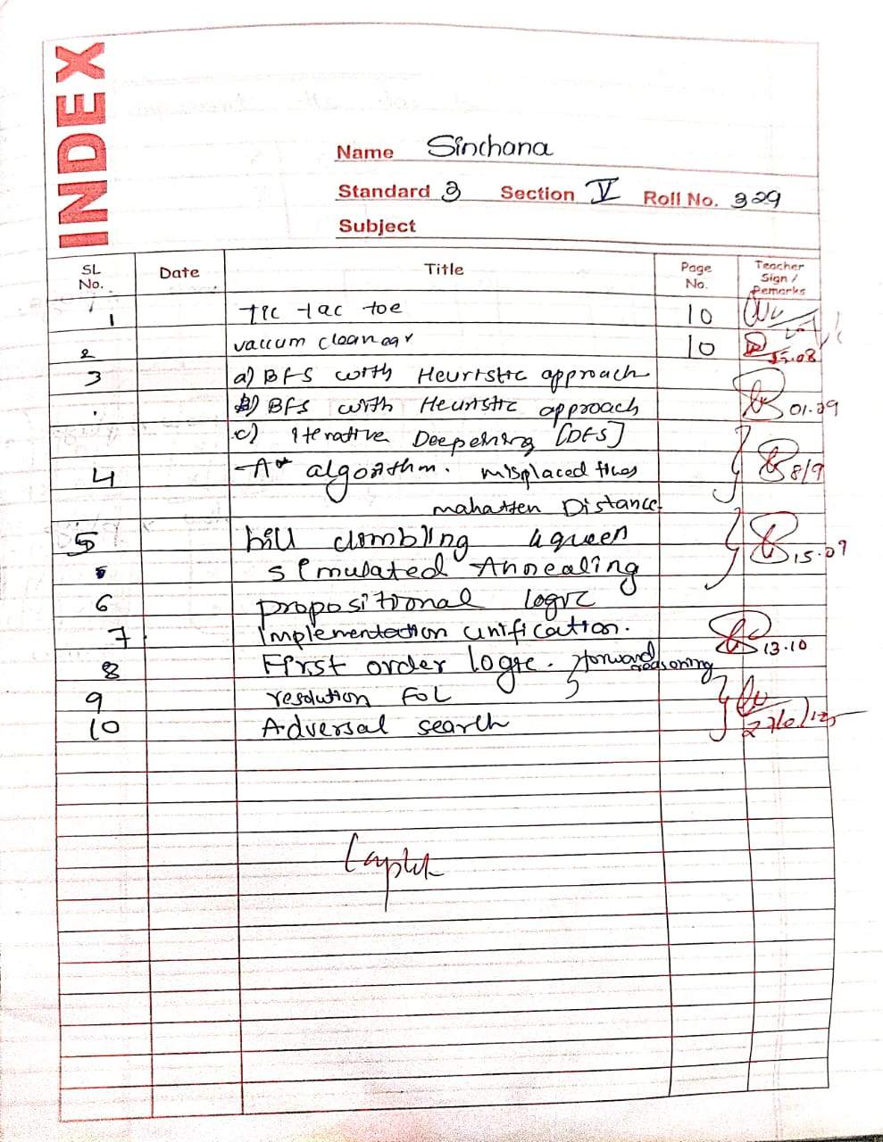
Github Link: https://github.com/sinchana329/AI
Program 1
Implement Tic –Tac –Toe Game
Implement vacuum cleaner agent

Algorithm:
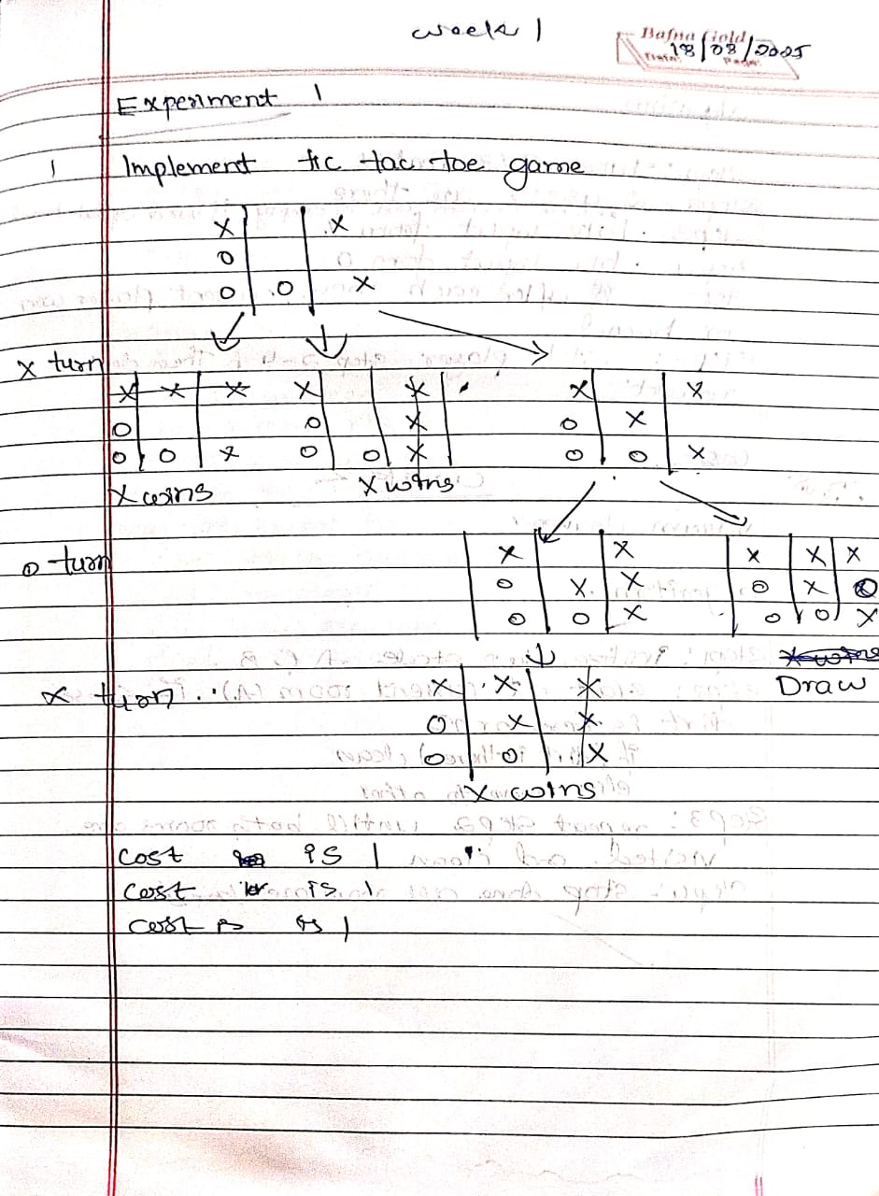

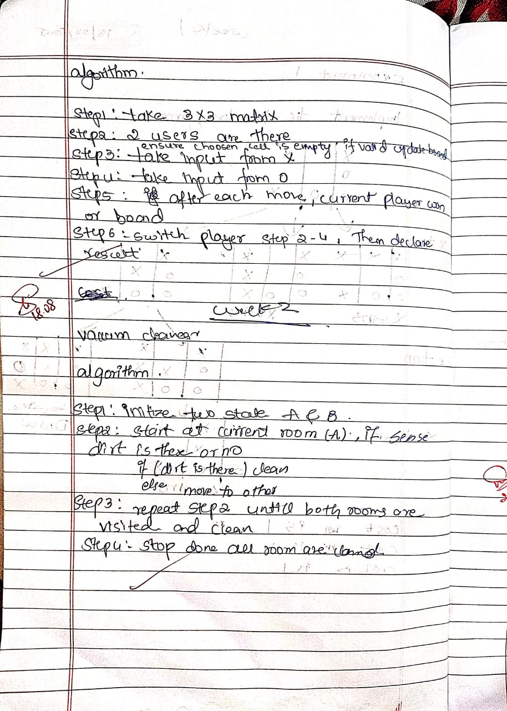
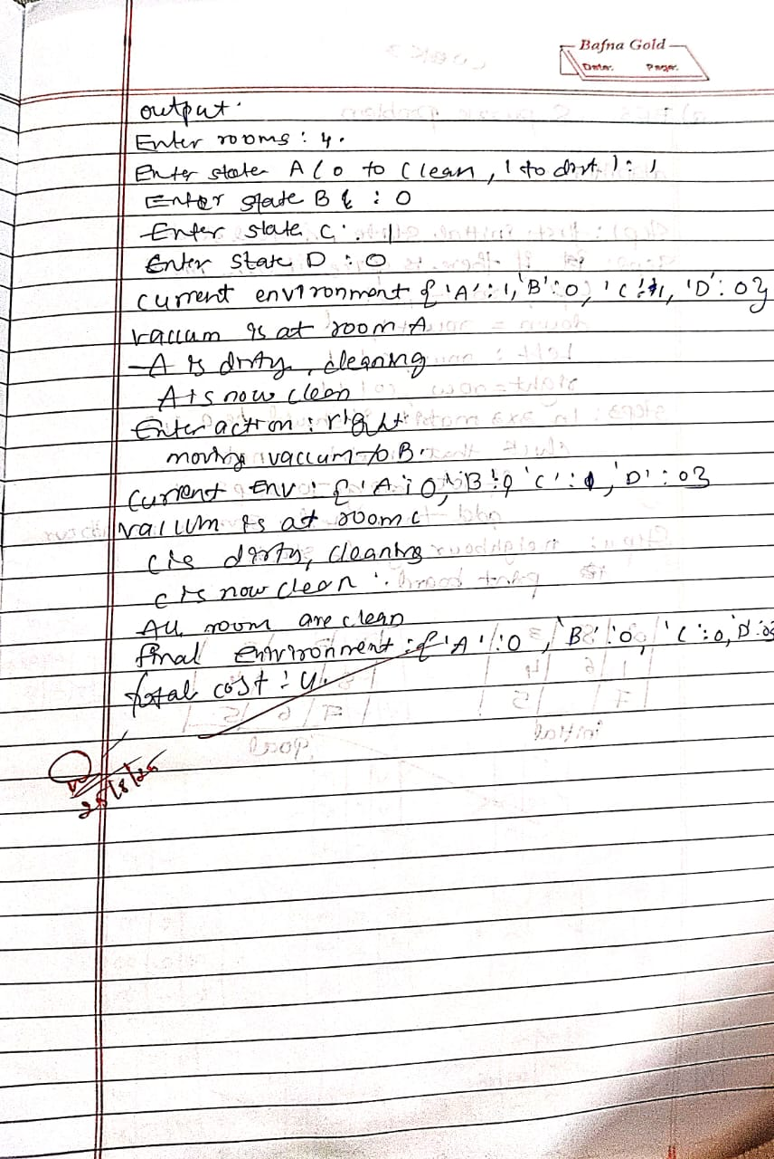

Code:
print("Sinchana")
print("1BM23CS329")

# tic tac toe game lab 1
name = input("enter your name ");
usn=input ("enter your usn");
def print_board(board):
for row in board:
print(" | ".join(row))
print("-" * 5)

def check_winner(board, player):

for i in range(3):
if all(board[i][j] == player for j in range(3)):
return True
if all(board[j][i] == player for j in range(3)):
return True
if all(board[i][i] == player for i in range(3)):
return True
if all(board[i][2 - i] == player for i in range(3)):
return True
return False

def is_full(board):
return all(board[i][j] != " " for i in range(3) for j in range(3))

def tic_tac_toe():
board = [[" " for _ in range(3)] for _ in range(3)]
current_player = "X"
path_cost = 0

while True:
print_board(board)
print(f"Player {current_player}'s turn.")

# Input move
row = int(input("Enter row (0-2): "))
col = int(input("Enter col (0-2): "))

if board[row][col] == " ":
board[row][col] = current_player
path_cost += 1
else:
print("Invalid move! Try again.")
continue

if check_winner(board, current_player):
print_board(board)
print(f"Player {current_player} wins!")
print(f"Path cost: {path_cost}")
break

if is_full(board):
print_board(board)
print("It's a draw!")
print(f"Path cost: {path_cost}")
break

current_player = "O" if current_player == "X" else "X"

tic_tac_toe()

Implement vacuum cleaner agent
print("Sinchana")
print("1BM23CS329")

def vacuum_cleaner_4_rooms_grid():

try:
state_A = int(input("Enter state of A (0 for clean, 1 for dirty): "))
state_B = int(input("Enter state of B (0 for clean, 1 for dirty): "))
state_C = int(input("Enter state of C (0 for clean, 1 for dirty): "))
state_D = int(input("Enter state of D (0 for clean, 1 for dirty): "))
location = input("Enter location (A, B, C, D): ").upper()

if (state_A not in (0, 1) or state_B not in (0, 1) or
state_C not in (0, 1) or state_D not in (0, 1) or
location not in ('A', 'B', 'C', 'D')):
raise ValueError("Invalid input! Enter 0 or 1 for states, and location as A/B/C/D.")
except ValueError as e:
print("Error:", e)
return

environment = {'A': state_A, 'B': state_B, 'C': state_C, 'D': state_D}
cost = 0
moves = {
'A': {'RIGHT': 'B', 'DOWN': 'C'},
'B': {'LEFT': 'A', 'DOWN': 'D'},
'C': {'UP': 'A', 'RIGHT': 'D'},
'D': {'UP': 'B', 'LEFT': 'C'}
}

while True:
print("\nCurrent Environment:", environment)
print("Vacuum is at Room", location)

if environment[location] == 1:
print(f"{location} is dirty. Cleaning...")
environment[location] = 0
cost += 1
print(f"{location} is now clean.")
else:
print(f"{location} is already clean.")

if all(state == 0 for state in environment.values()):
print("\nAll rooms are clean. Turning vacuum off.")
break

move = input("Enter action (LEFT / RIGHT / UP / DOWN / STAY / EXIT): ").upper()

if move in moves[location]:
new_location = moves[location][move]
print(f"Moving vacuum {move} to {new_location}.")
location = new_location
cost += 1

elif move == "STAY":
print("Staying in the same room. (No cost)")

elif move == "EXIT":
print("Exiting manually.")
break

else:
print("Invalid move from this room! Try again.")

print("\nFinal Environment:", environment)
print("Total Cost:", cost)

vacuum_cleaner_4_rooms_grid()

PROGRAM-2
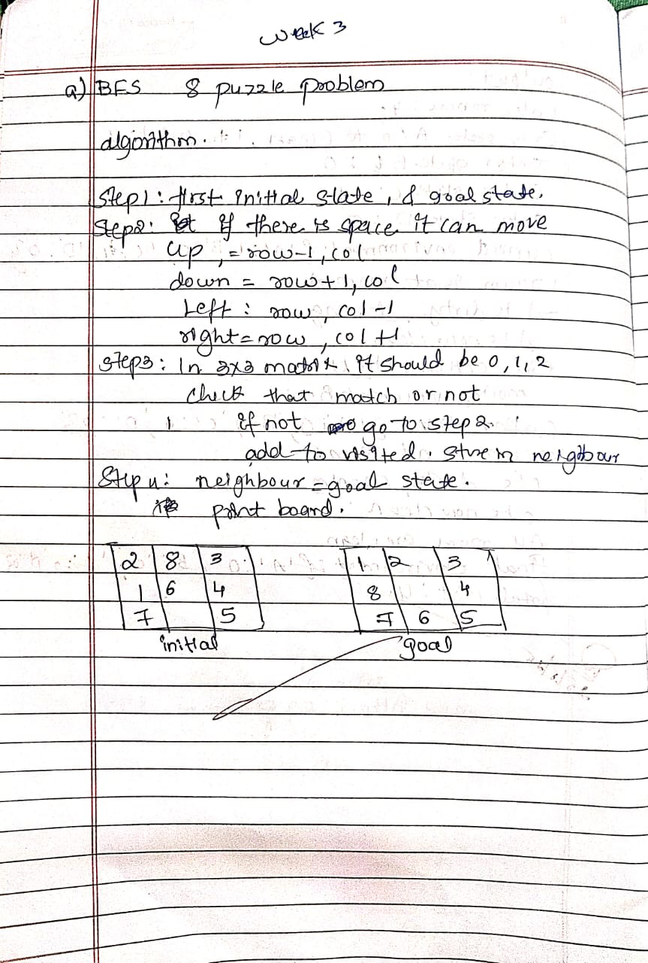
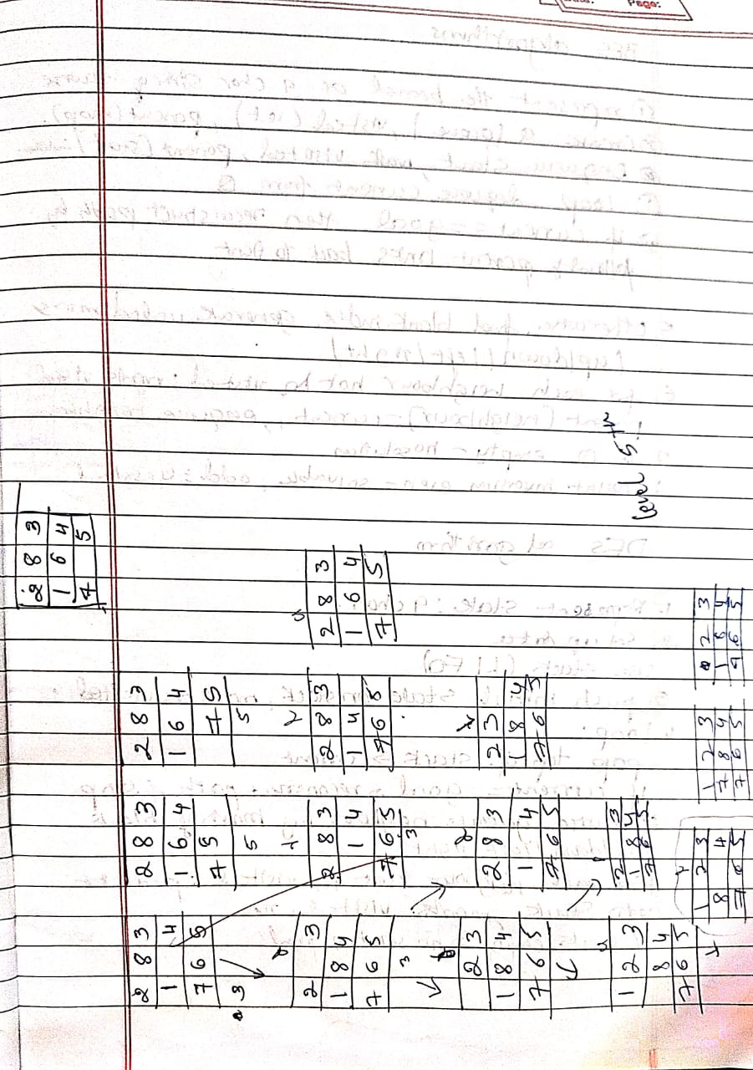
print("Sinchana")
print("1BM23CS329")

from copy import deepcopy

GOAL_STATE = [[1, 2, 3],
[8, 0, 4],
[7, 6, 5]]

DIRECTIONS = [(-1, 0), (1, 0), (0, -1), (0, 1)]

def is_valid(x, y):
return 0 <= x < 3 and 0 <= y < 3

def serialize(state):
return str(state)

def find_zero(state):
for i in range(3):
for j in range(3):
if state[i][j] == 0:
return i, j

def get_neighbors(state):
neighbors = []
x, y = find_zero(state)

for dx, dy in DIRECTIONS:
nx, ny = x + dx, y + dy
if is_valid(nx, ny):
new_state = deepcopy(state)
new_state[x][y], new_state[nx][ny] = new_state[nx][ny], new_state[x][y]
neighbors.append(new_state)

return neighbors

def dfs(start_state, max_depth=30):
visited = set()
path = []
solution_path = []
found = False

def dfs_recursive(state, depth):
nonlocal found, solution_path
if depth > max_depth or found:
return
serial = serialize(state)
if serial in visited:
return
visited.add(serial)
path.append(state)

if state == GOAL_STATE:
solution_path = path.copy()
found = True
return

for neighbor in get_neighbors(state):
dfs_recursive(neighbor, depth + 1)

path.pop()
visited.remove(serial)

dfs_recursive(start_state, 0)

if found:
return solution_path, len(solution_path) - 1
else:
return None, -1

if __name__ == "__main__":
start = [[2, 8, 3],
[1, 6, 4],
[7, 0, 5]]

path, cost = dfs(start, max_depth=50)

if path:
print(f"DFS found a path with cost = {cost}:")
for step in path:
for row in step:
print(row)
print("------")
else:
print("No solution found within depth limit.") 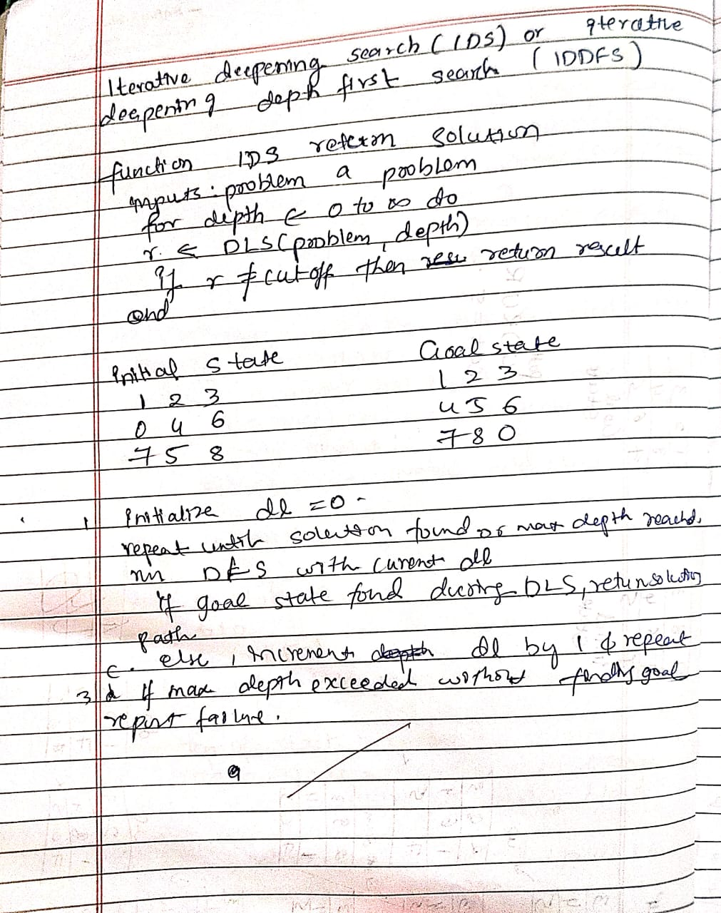

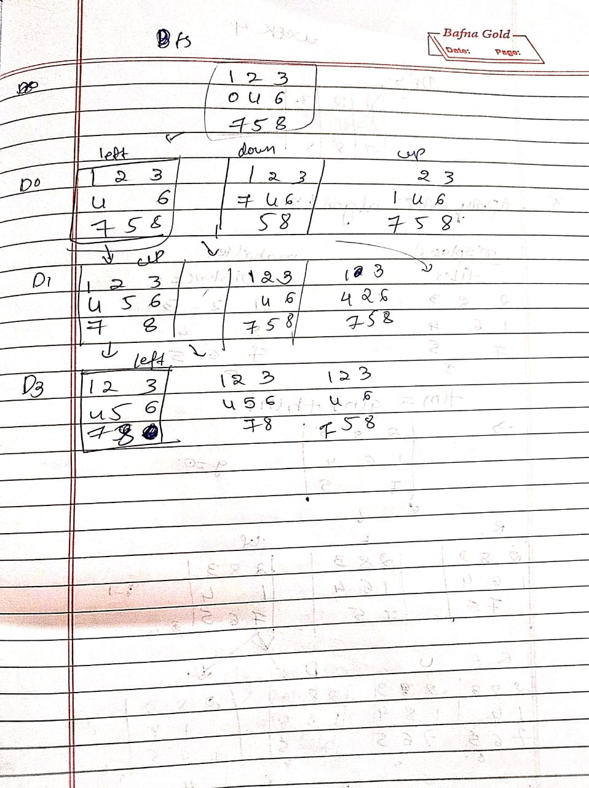
ITERATIVE DFS
from copy import deepcopy
print("soham Hathi")
print("1BM23CS335")

# Goal state
GOAL_STATE = [[1, 2, 3],
[8, 0, 4],
[7, 6, 5]]

DIRECTIONS = {'UP': (-1, 0), 'DOWN': (1, 0), 'LEFT': (0, -1), 'RIGHT': (0, 1)}

def find_blank(state):
for i in range(3):
for j in range(3):
if state[i][j] == 0:
return i, j
return None

def is_goal(state):
return state == GOAL_STATE

def get_successors(state):
successors = []
x, y = find_blank(state)
for move, (dx, dy) in DIRECTIONS.items():
new_x, new_y = x + dx, y + dy
if 0 <= new_x < 3 and 0 <= new_y < 3:
new_state = deepcopy(state)
new_state[x][y], new_state[new_x][new_y] = new_state[new_x][new_y], new_state[x][y]
successors.append((new_state, move))
return successors

def depth_limited_search(state, depth, path, visited):
if is_goal(state):
return path

if depth == 0:
return None

visited.append(state)

for successor, move in get_successors(state):
if successor not in visited:
result = depth_limited_search(successor, depth - 1, path + [move], visited)
if result is not None:
return result

visited.pop()
return None

# Iterative Deepening DFS
def iterative_deepening_search(start_state, max_depth=50):
for depth in range(max_depth):
print(f"Trying depth limit: {depth}")
visited = []
result = depth_limited_search(start_state, depth, [], visited)
if result is not None:
return result
return None

if __name__ == "__main__":

initial_state = [[2, 8, 3],
[1 ,6, 4],
[7, 0, 5]]

solution = iterative_deepening_search(initial_state)

if solution:
print("\nSolution found!")
print("Moves to solve:", solution)
print("Number of moves:", len(solution))
else:
print("No solution found within depth limit.")

PROGRAM-3

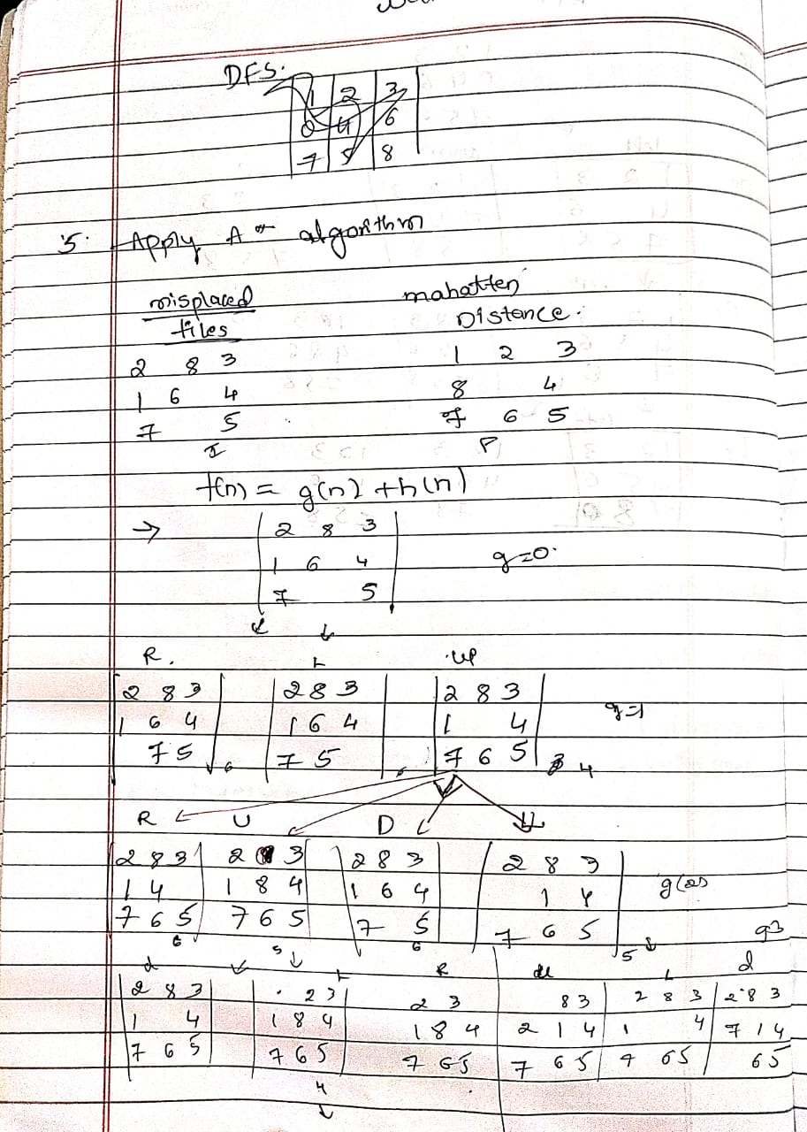

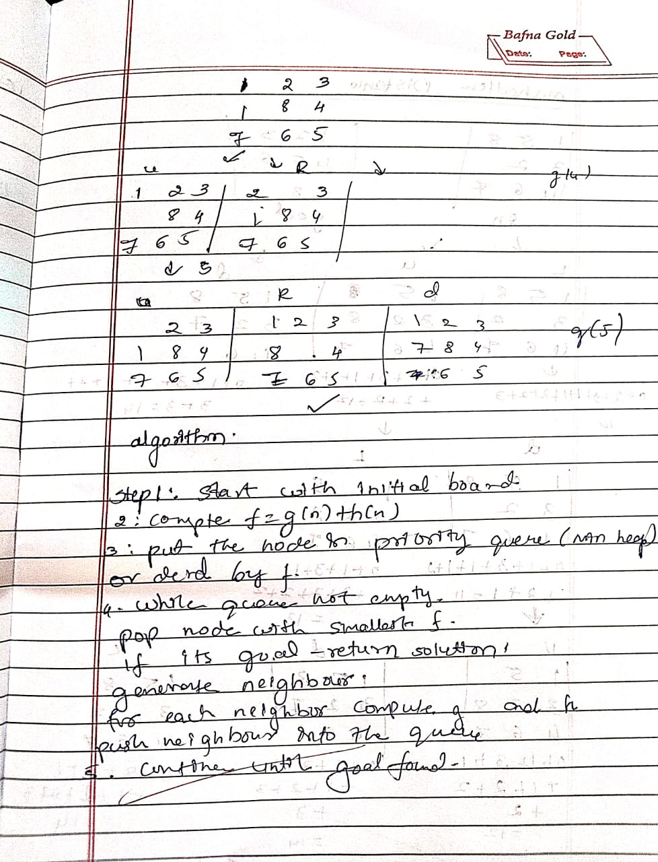
import heapq
print("Sinchana")
print("1BM23CS329")

def manhattan_distance(state, goal):
"""Calculate total Manhattan distance of all tiles from their goal positions."""
goal_positions = {}
for i in range(3):
for j in range(3):
goal_positions[goal[i][j]] = (i, j)

dist = 0
for i in range(3):
for j in range(3):
tile = state[i][j]
if tile != 0:
goal_i, goal_j = goal_positions[tile]
dist += abs(i - goal_i) + abs(j - goal_j)
return dist

def get_neighbors(state):
neighbors = []
for i in range(3):
for j in range(3):
if state[i][j] == 0:
x, y = i, j
directions = [(-1,0),(1,0),(0,-1),(0,1)]
for dx, dy in directions:
nx, ny = x + dx, y + dy
if 0 <= nx < 3 and 0 <= ny < 3:
new_state = [list(row) for row in state]
new_state[x][y], new_state[nx][ny] = new_state[nx][ny], new_state[x][y]
neighbors.append(tuple(tuple(row) for row in new_state))
return neighbors

def print_state(state):
for row in state:
print(' '.join(str(x) if x != 0 else ' ' for x in row))
print()

def get_user_state(prompt):
print(prompt)
print("Enter 9 numbers separated by space, use 0 for blank tile (e.g. '2 8 3 1 6 4 7 0 5'):")
while True:
try:
entries = list(map(int, input().strip().split()))
if len(entries) != 9 or set(entries) != set(range(9)):
raise ValueError
break
except ValueError:
print("Invalid input! Enter exactly 9 unique digits from 0 to 8 separated by spaces.")
return tuple(tuple(entries[i*3:(i+1)*3]) for i in range(3))

def a_star_verbose(start_state, goal_state):
open_set = []
start_h = manhattan_distance(start_state, goal_state)
heapq.heappush(open_set, (start_h, 0, start_state, [])) # (f, g, state, path)

closed_set = set()
step_counter = 0

while open_set:
f, g, current, path = heapq.heappop(open_set)
step_counter += 1

print(f"Step {step_counter}:")
print(f"Current state with f = g + h = {g} + {f - g} = {f}")
print_state(current)

if current == goal_state:
print("Goal reached!")
return path + [current]

if current in closed_set:
print("This state has already been visited. Skipping.\n")
continue
closed_set.add(current)

neighbors = get_neighbors(current)
print(f"Expanding neighbors ({len(neighbors)}):")
for n in neighbors:
if n not in closed_set:
h = manhattan_distance(n, goal_state)
new_g = g + 1
new_f = new_g + h
print(f"Neighbor state with g={new_g}, h={h}, f={new_f}:")
print_state(n)
heapq.heappush(open_set, (new_f, new_g, n, path + [current]))
else:
print("Neighbor already visited, skipping.")
print("-----\n")
return None

if __name__ == "__main__":
start = get_user_state("Enter the START state:")
goal = get_user_state("Enter the GOAL state:")
print("\nStarting A* search with Manhattan distance heuristic...\n")
solution = a_star_verbose(start, goal)

if solution:
print(f"\nSolution found in {len(solution)-1} moves:\n")
for step_num, step in enumerate(solution):
print(f"Step {step_num}:")
print_state(step)
else:
print("No solution found.")
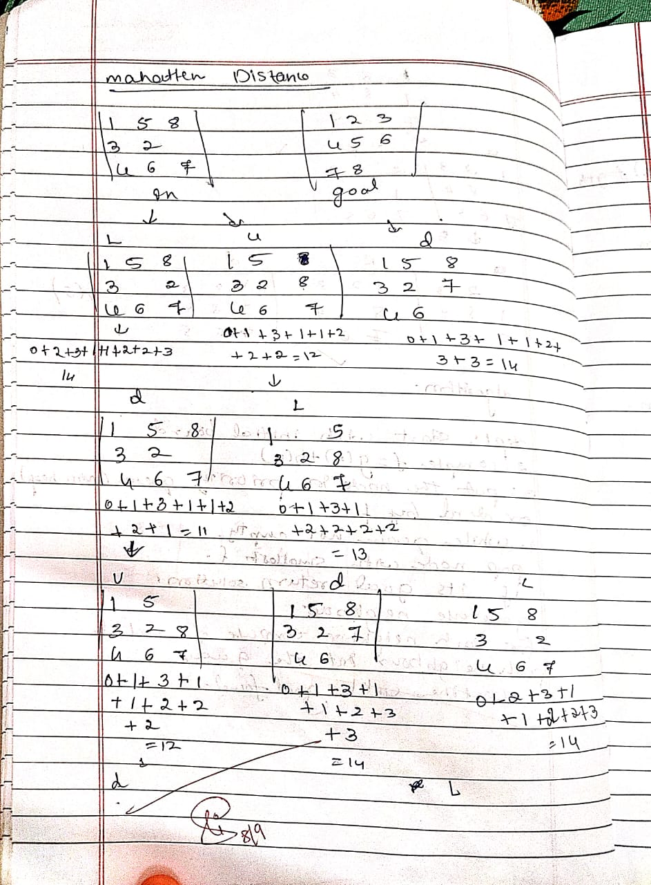
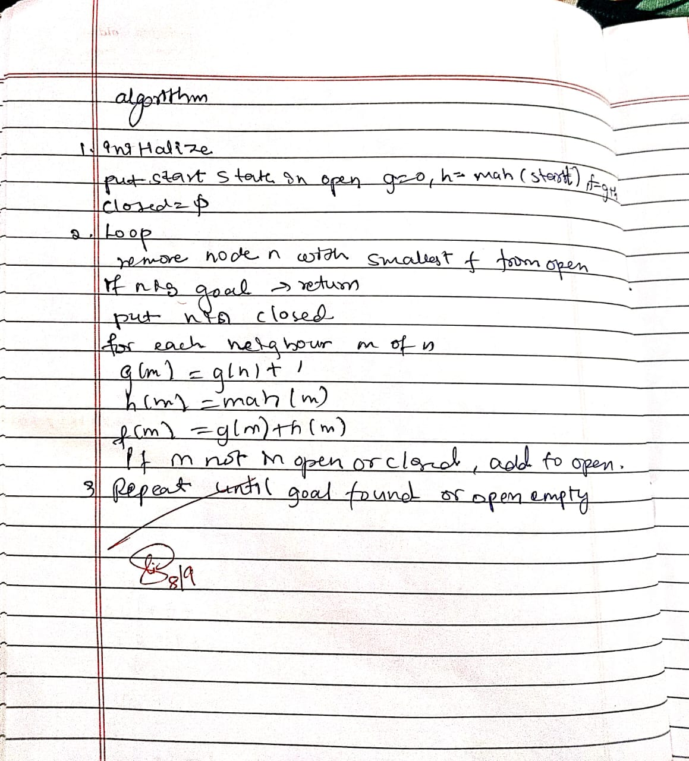
MANHATTAN DISTANCE
import heapq
print("Sinchana")
print("1BM23CS329")

def manhattan_distance(state, goal):
"""Calculate total Manhattan distance of all tiles from their goal positions."""
goal_positions = {}
for i in range(3):
for j in range(3):
goal_positions[goal[i][j]] = (i, j)

dist = 0
for i in range(3):
for j in range(3):
tile = state[i][j]
if tile != 0:
goal_i, goal_j = goal_positions[tile]
dist += abs(i - goal_i) + abs(j - goal_j)
return dist

def get_neighbors(state):
neighbors = []
for i in range(3):
for j in range(3):
if state[i][j] == 0:
x, y = i, j
directions = [(-1,0),(1,0),(0,-1),(0,1)]
for dx, dy in directions:
nx, ny = x + dx, y + dy
if 0 <= nx < 3 and 0 <= ny < 3:
new_state = [list(row) for row in state]
new_state[x][y], new_state[nx][ny] = new_state[nx][ny], new_state[x][y]
neighbors.append(tuple(tuple(row) for row in new_state))
return neighbors

def print_state(state):
for row in state:
print(' '.join(str(x) if x != 0 else ' ' for x in row))
print()

def get_user_state(prompt):
print(prompt)
print("Enter 9 numbers separated by space, use 0 for blank tile (e.g. '2 8 3 1 6 4 7 0 5'):")
while True:
try:
entries = list(map(int, input().strip().split()))
if len(entries) != 9 or set(entries) != set(range(9)):
raise ValueError
break
except ValueError:
print("Invalid input! Enter exactly 9 unique digits from 0 to 8 separated by spaces.")
return tuple(tuple(entries[i*3:(i+1)*3]) for i in range(3))

def a_star_verbose(start_state, goal_state):
open_set = []
start_h = manhattan_distance(start_state, goal_state)
heapq.heappush(open_set, (start_h, 0, start_state, [])) # (f, g, state, path)

closed_set = set()
step_counter = 0

while open_set:
f, g, current, path = heapq.heappop(open_set)
step_counter += 1

print(f"Step {step_counter}:")
print(f"Current state with f = g + h = {g} + {f - g} = {f}")
print_state(current)

if current == goal_state:
print("Goal reached!")
return path + [current]

if current in closed_set:
print("This state has already been visited. Skipping.\n")
continue
closed_set.add(current)

neighbors = get_neighbors(current)
print(f"Expanding neighbors ({len(neighbors)}):")
for n in neighbors:
if n not in closed_set:
h = manhattan_distance(n, goal_state)
new_g = g + 1
new_f = new_g + h
print(f"Neighbor state with g={new_g}, h={h}, f={new_f}:")
print_state(n)
heapq.heappush(open_set, (new_f, new_g, n, path + [current]))
else:
print("Neighbor already visited, skipping.")
print("-----\n")
return None

if __name__ == "__main__":
start = get_user_state("Enter the START state:")
goal = get_user_state("Enter the GOAL state:")
print("\nStarting A* search with Manhattan distance heuristic...\n")
solution = a_star_verbose(start, goal)

if solution:
print(f"\nSolution found in {len(solution)-1} moves:\n")
for step_num, step in enumerate(solution):
print(f"Step {step_num}:")
print_state(step)
else:
print("No solution found.")

PROGRAM-4
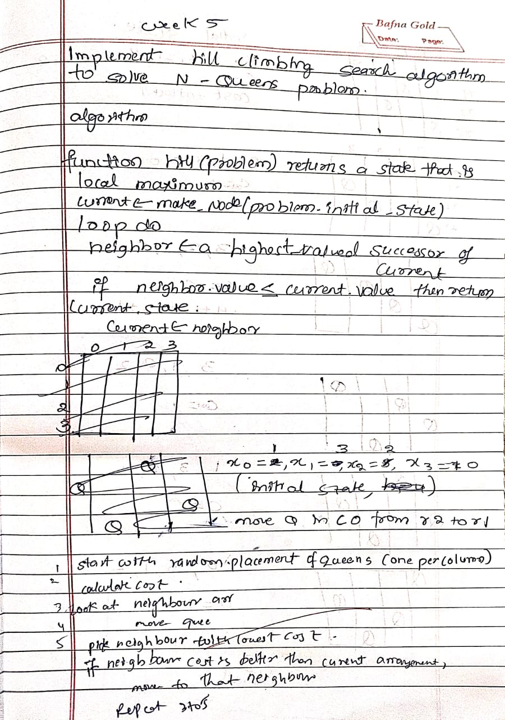
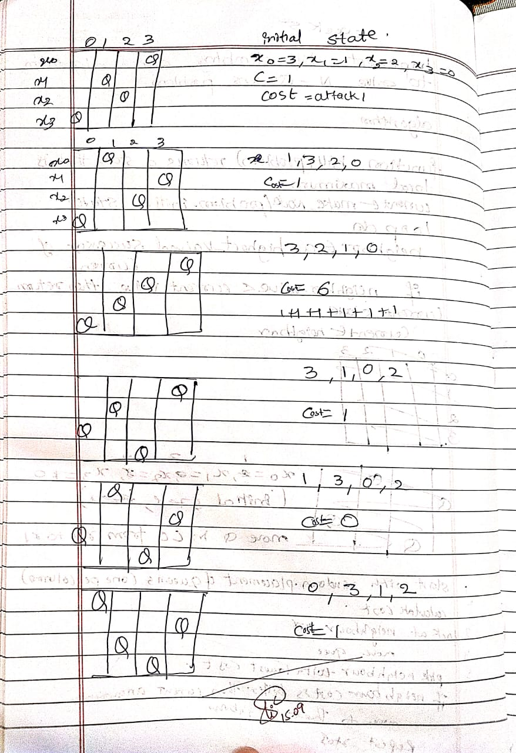
import random
import copy
print("Sinchana")
print("1BM23CS329")

N = 4

def print_board(state):
for row in range(N):
line = ""
for col in range(N):
if state[col] == row:
line += " Q "
else:
line += " . "
print(line)
print()

def heuristic(state):
"""Calculate the number of pairs of queens attacking each other."""
h = 0
for i in range(N):
for j in range(i + 1, N):
if state[i] == state[j] or abs(state[i] - state[j]) == abs(i - j):
h += 1
return h

def get_neighbors(state):
"""Generate all neighboring states (each queen moved to another row in its column)."""
neighbors = []
for col in range(N):
for row in range(N):
if state[col] != row:
neighbor = list(state)
neighbor[col] = row
neighbors.append(neighbor)
return neighbors

def hill_climbing(initial_state):
current = initial_state
step = 0

while True:
print(f"\n🔄 Step {step}:")
print(f"Current state: {current}")
print(f"Heuristic: {heuristic(current)}")
print_board(current)

neighbors = get_neighbors(current)
neighbor_heuristics = [(neighbor, heuristic(neighbor)) for neighbor in neighbors]

print("Generated neighbors and their heuristics:")
for i, (neighbor, h) in enumerate(neighbor_heuristics):
print(f"{i + 1}. {neighbor} -> h = {h}")

best_neighbor, best_h = min(neighbor_heuristics, key=lambda x: x[1])

if best_h >= heuristic(current):

print("\n Local minimum reached. Stopping.")
break

current = best_neighbor
step += 1

if best_h == 0:
print("\n✅ Goal state found!")
print_board(current)
break

return current

random_initial_state = [random.randint(0, N - 1) for _ in range(N)]
print(" Initial Random State:", random_initial_state)

final_state = hill_climbing(random_initial_state)
print(" Final State:", final_state)
print("Final Heuristic:", heuristic(final_state))

PROGRAM-5
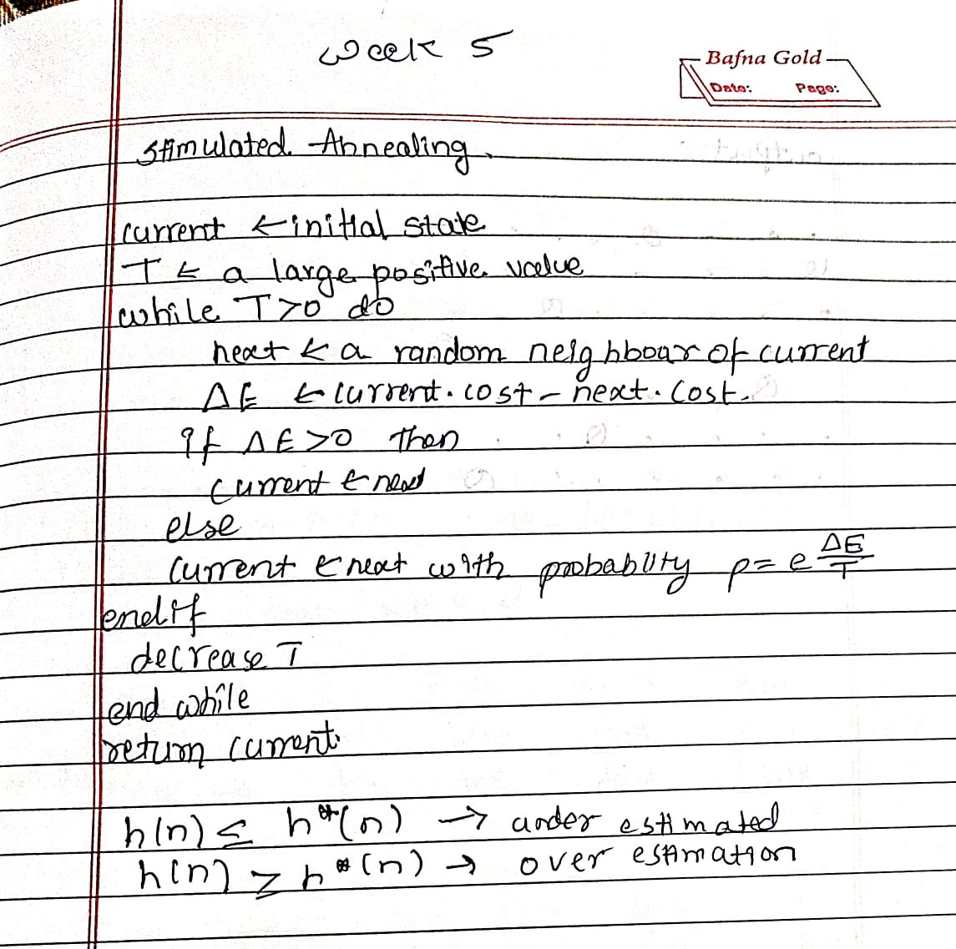
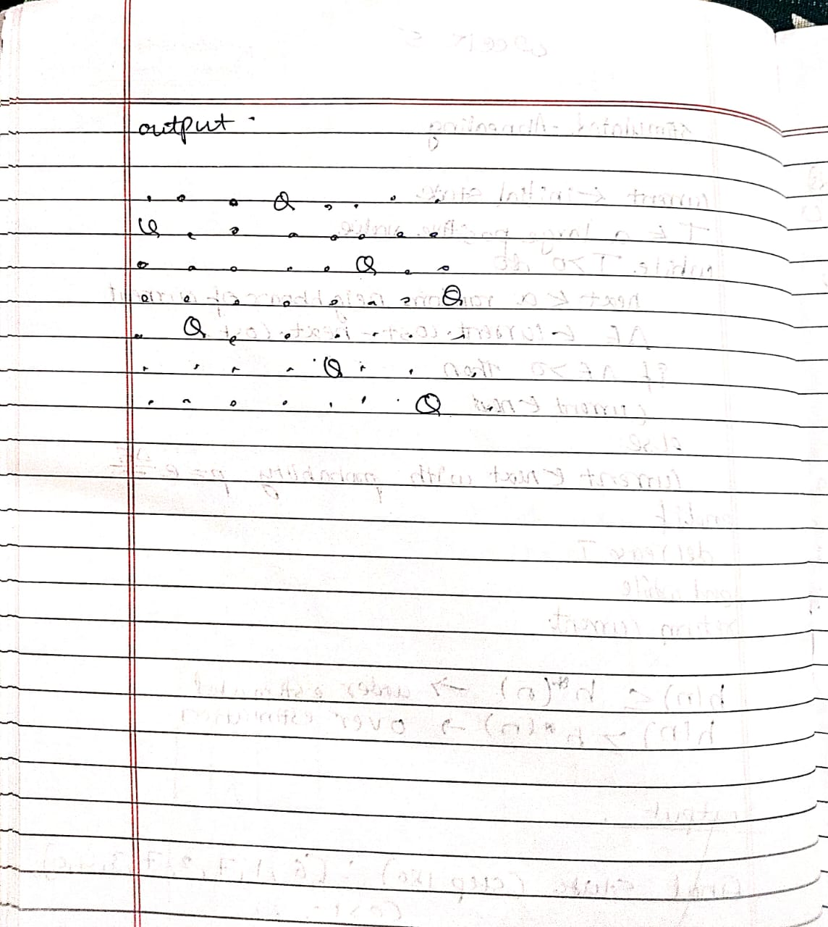

import numpy as np
print("Sinchana")
print("1BM23CS329")

def compute_conflicts(queens):
"""Compute number of pairs of queens attacking each other."""
conflicts = 0
n = len(queens)
for i in range(n):
for j in range(i + 1, n):
if queens[i] == queens[j] or abs(queens[i] - queens[j]) == abs(i - j):
conflicts += 1
return conflicts

def random_neighbor(queens):
"""Generate a neighbor by swapping two random positions."""
n = len(queens)
new_queens = queens.copy()
i, j = np.random.choice(n, 2, replace=False)
new_queens[i], new_queens[j] = new_queens[j], new_queens[i]
return new_queens

def simulated_annealing(n, initial_temp=100, cooling_rate=0.95, max_iter=10000):
queens = np.arange(n) # Start with a permutation (0 to n-1)
current_conflicts = compute_conflicts(queens)
best_queens = queens.copy()
best_conflicts = current_conflicts
temp = initial_temp

for i in range(max_iter):
if temp <= 1e-3 or best_conflicts == 0:
break

candidate = random_neighbor(queens)
candidate_conflicts = compute_conflicts(candidate)
delta = candidate_conflicts - current_conflicts

if delta < 0 or np.random.rand() < np.exp(-delta / temp):
queens = candidate
current_conflicts = candidate_conflicts

if current_conflicts < best_conflicts:
best_queens = queens.copy()
best_conflicts = current_conflicts

temp *= cooling_rate

return best_queens, n - best_conflicts

n = 8
solution, non_attacking_queens = simulated_annealing(n)
print(f"The best position found is: {solution}")
print(f"The number of queens that are not attacking each other is: {non_attacking_queens}")

PROGRAM-6
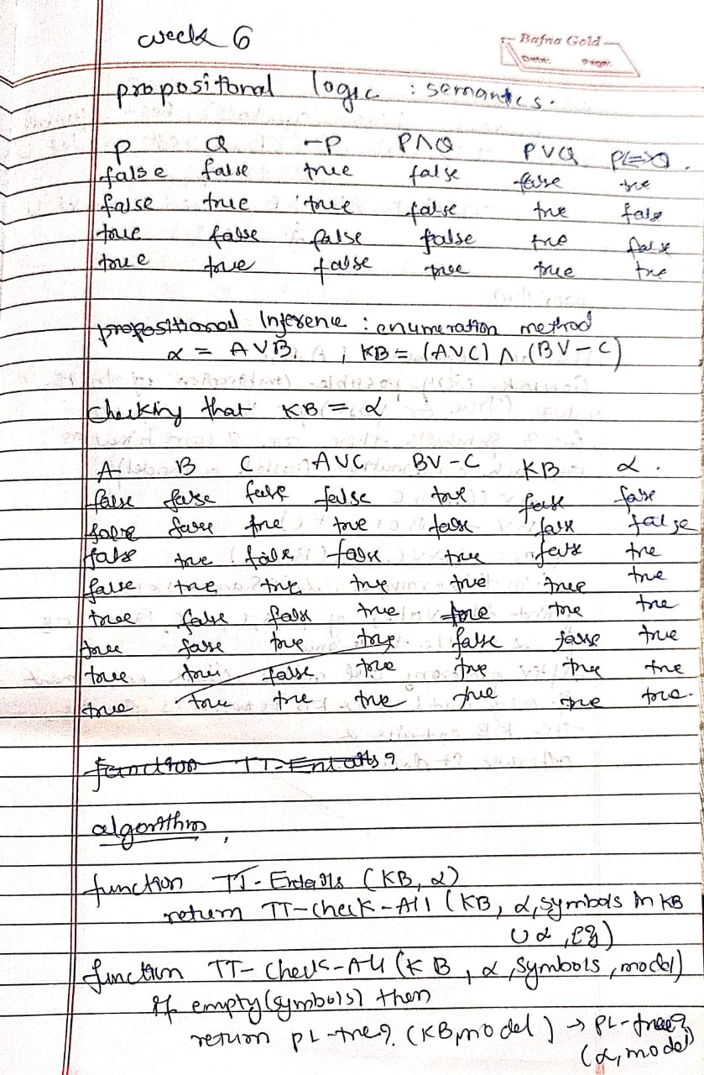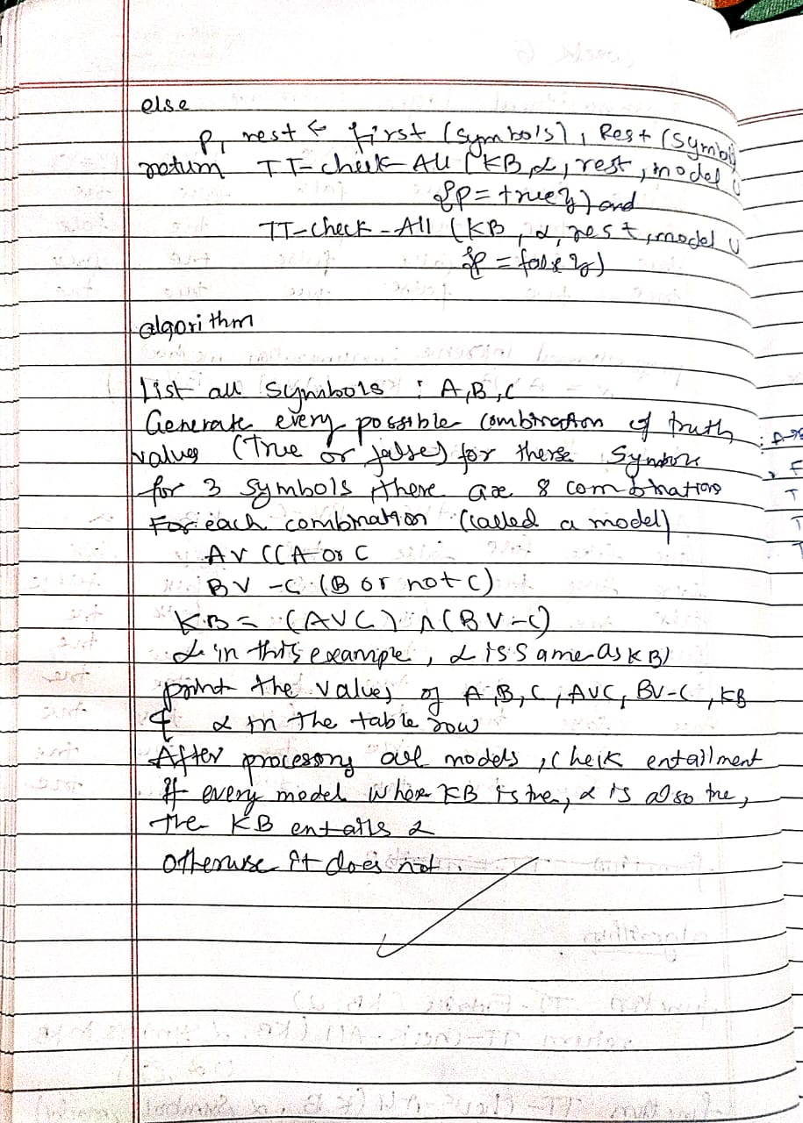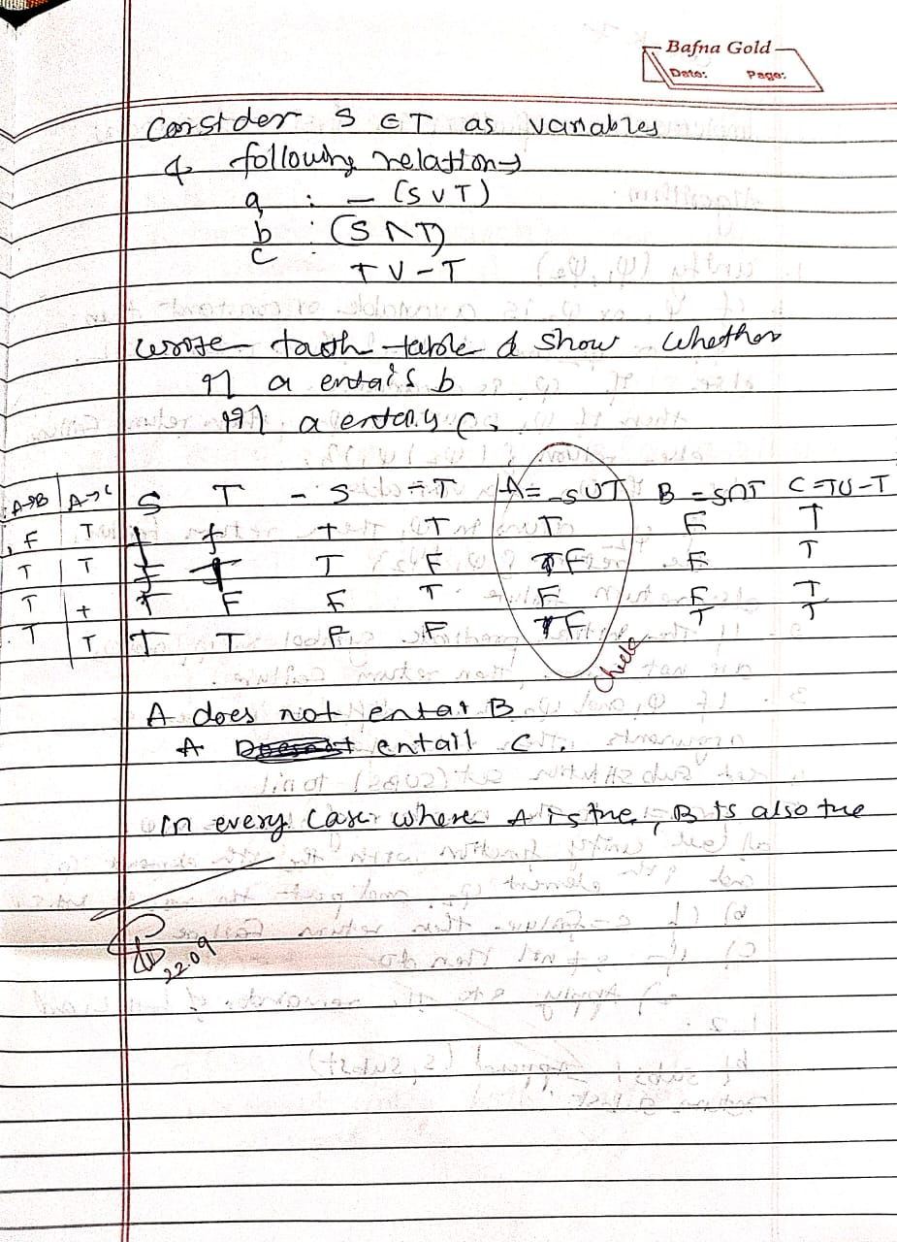
print("Sinchana")
print("1BM23CS329")
from itertools import product

def pl_true(sentence, model):
if sentence == "A":
return model["A"]
elif sentence == "B":
return model["B"]
elif sentence == "C":
return model["C"]
elif sentence == "A_or_C":
return model["A"] or model["C"]
elif sentence == "B_or_not_C":
return model["B"] or (not model["C"])
elif sentence == "KB":
return (model["A"] or model["C"]) and (model["B"] or (not model["C"]))
elif sentence == "alpha":

return model["alpha"]
else:
return False

def print_truth_table():
print(f"{'A':<7} {'B':<7} {'C':<7} {'A∨C':<7} {'B∨¬C':<7} {'KB':<7} {'α':<7}")
print("-"*50)

all_rows = []
for values in product([False, True], repeat=3):
model = {"A": values[0], "B": values[1], "C": values[2]}

model["A_or_C"] = pl_true("A_or_C", model)
model["B_or_not_C"] = pl_true("B_or_not_C", model)
model["KB"] = pl_true("KB", model)
model["alpha"] = model["KB"]

all_rows.append(model)

print(f"{str(model['A']).lower():<7} {str(model['B']).lower():<7} {str(model['C']).lower():<7} "
f"{str(model['A_or_C']).lower():<7} {str(model['B_or_not_C']).lower():<7} "
f"{str(model['KB']).lower():<7} {str(model['alpha']).lower():<7}")

return all_rows

def tt_entails(all_rows):

for model in all_rows:
if model["KB"] and not model["alpha"]:
return False
return True

def main():
all_rows = print_truth_table()
entails = tt_entails(all_rows)
print("\nDoes KB entail α? ", entails)

if __name__ == "__main__":

PROGRAM-7
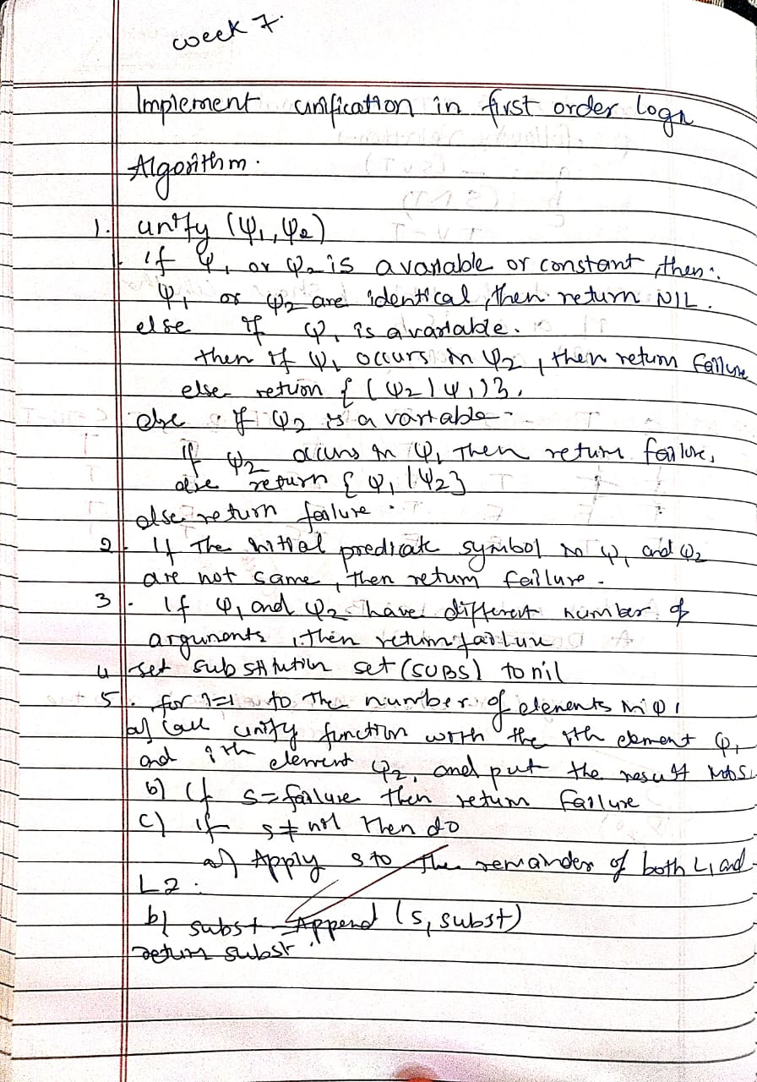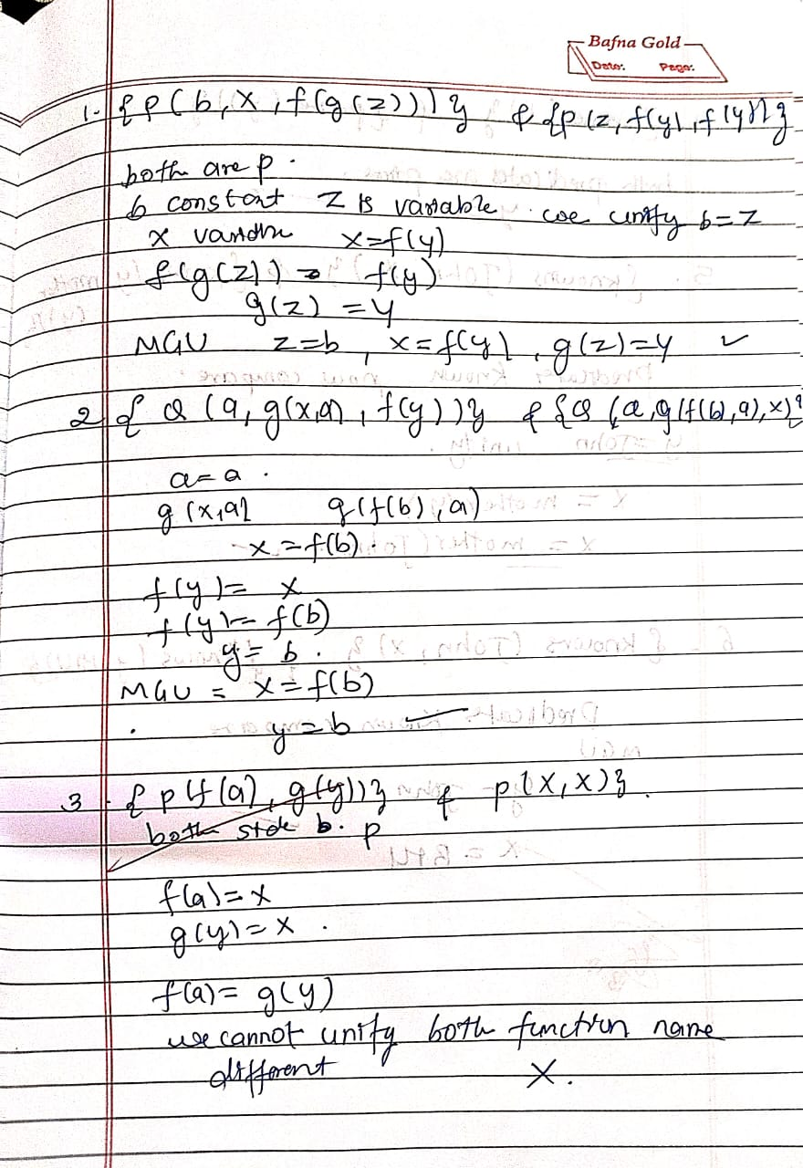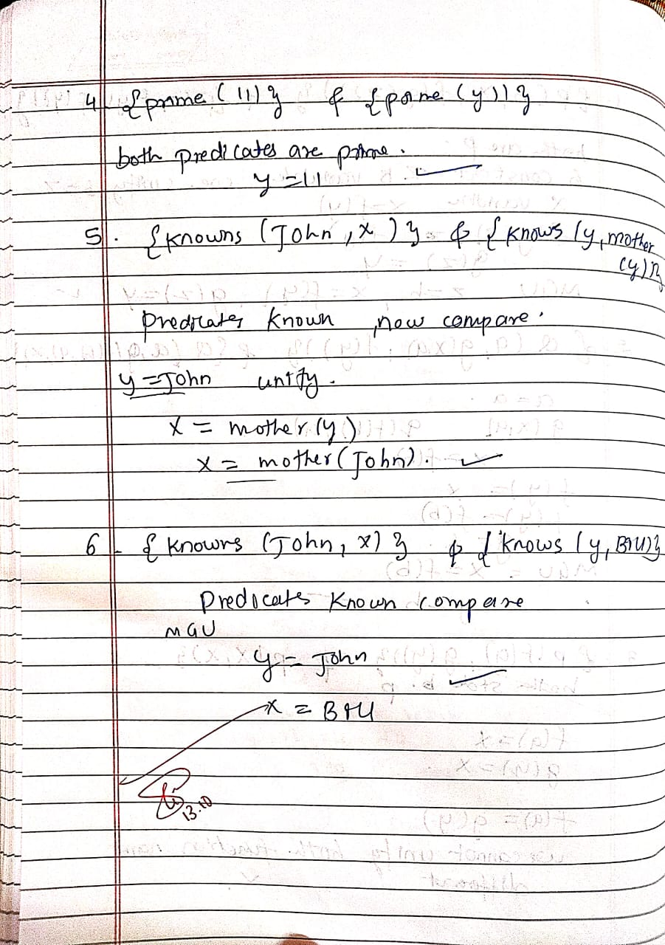
# Unification algorithm (fixed parser & example)
print("Sinchana")
print("1BM23CS329")

import re

def is_variable(x):
"""Variable if it is a string and starts with an uppercase letter."""
return isinstance(x, str) and len(x) > 0 and x[0].isupper()

def unify(x, y, subs=None):
if subs is None:
subs = {}
if x == y:
return subs
if is_variable(x):
return unify_var(x, y, subs)
if is_variable(y):
return unify_var(y, x, subs)
if isinstance(x, tuple) and isinstance(y, tuple):
if x[0] != y[0] or len(x[1]) != len(y[1]):
return None
for a, b in zip(x[1], y[1]):
subs = unify(apply_subs(a, subs), apply_subs(b, subs), subs)
if subs is None:
return None
return subs
return None

def unify_var(var, x, subs):
if var in subs:
return unify(subs[var], x, subs)
elif is_variable(x) and x in subs:
return unify(var, subs[x], subs)
elif occur_check(var, x, subs):
return None
else:
subs[var] = x
return subs

def occur_check(var, x, subs):
if var == x:
return True
elif isinstance(x, tuple):
return any(occur_check(var, arg, subs) for arg in x[1])
elif isinstance(x, str) and is_variable(x) and x in subs:
return occur_check(var, subs[x], subs)
return False

def apply_subs(term, subs):
if isinstance(term, str) and is_variable(term) and term in subs:
return apply_subs(subs[term], subs)
elif isinstance(term, tuple):
return (term[0], [apply_subs(t, subs) for t in term[1]])
return term

def parse_term(expr):
expr = expr.strip()
# strip outer braces if present, e.g. "{ ... }"
if expr.startswith('{') and expr.endswith('}'):
expr = expr[1:-1].strip()
if '(' not in expr:
return expr
functor = expr[:expr.index('(')].strip()
args = expr[expr.index('(')+1:-1]
return (functor, parse_args(args))

def parse_args(s):
args, level, current = [], 0, ''
for ch in s:
if ch == ',' and level == 0:
args.append(parse_term(current.strip()))
current = ''
else:
if ch == '(':
level += 1
elif ch == ')':
level -= 1
current += ch
if current.strip():
args.append(parse_term(current.strip()))
return args
expr1 = "prime(11)"
expr2 = "prime(Y)" # NOTE: Y is uppercase -> variable

term1 = parse_term(expr1)
term2 = parse_term(expr2)

result = unify(term1, term2)

if result:
print("MGU:", result)
else:
print("No unifier found.")

PROGRAM 8
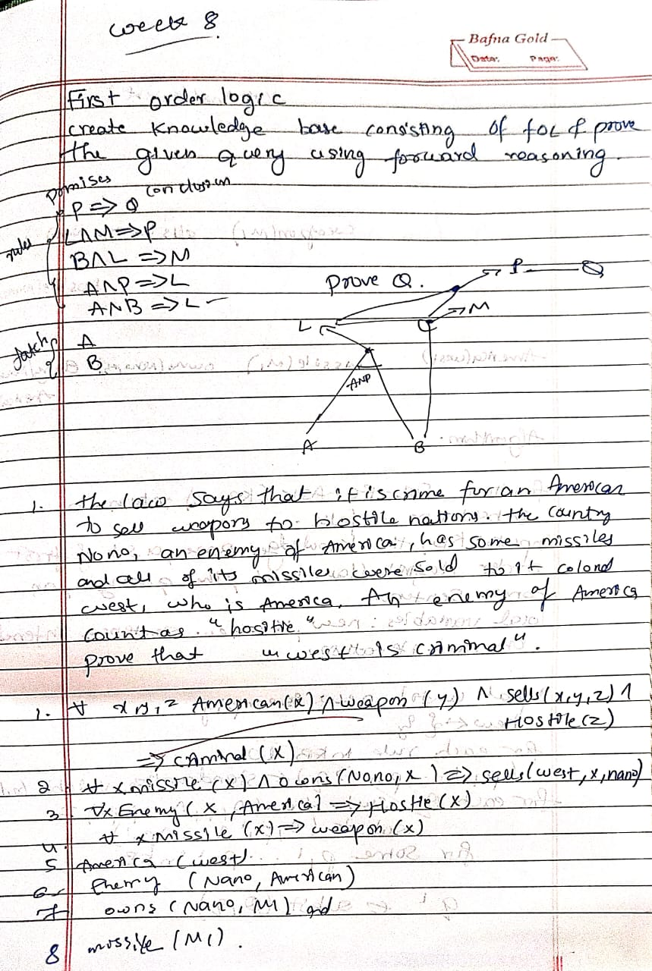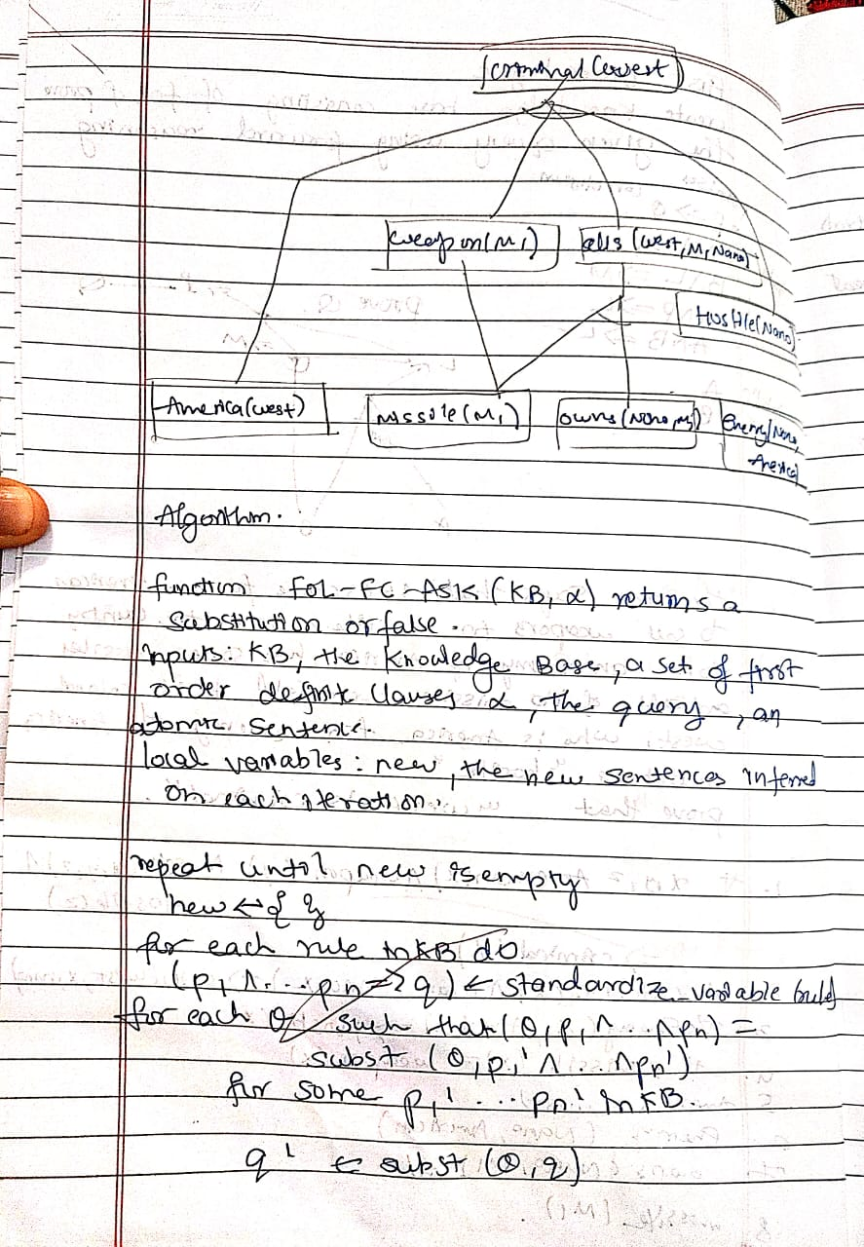
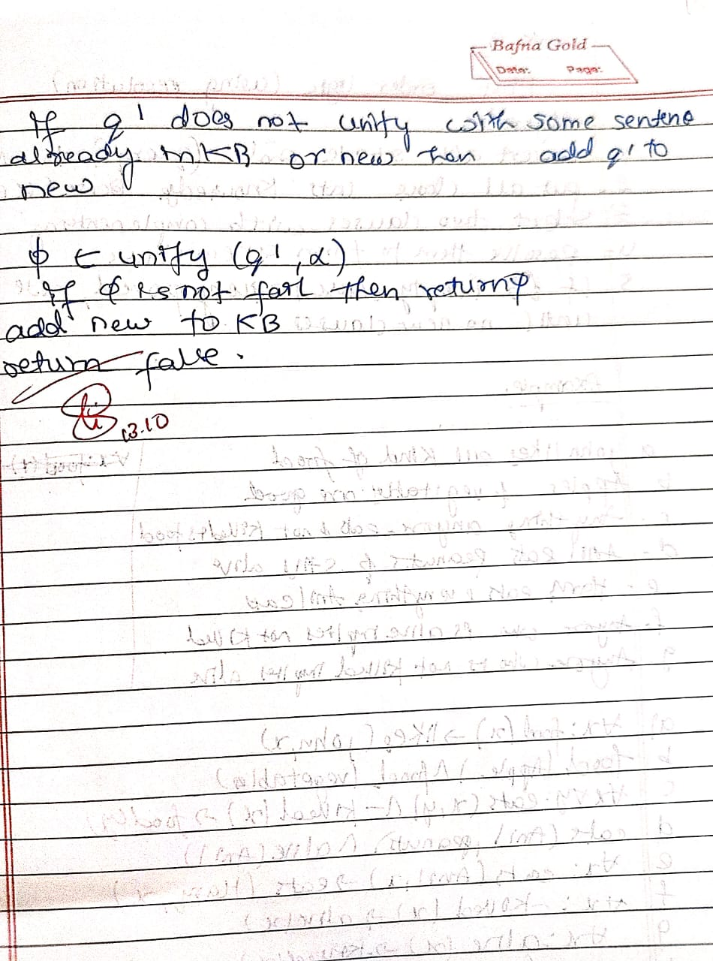
import copy
from itertools import product

print("Sinchana")
print("1BM23CS329")

def is_variable(x):
return isinstance(x, str) and x[0].islower()

def substitute(expr, subs):
if isinstance(expr, list):
return [substitute(e, subs) for e in expr]
else:
return subs.get(expr, expr)

def unify(x, y, subs=None):
if subs is None:
subs = {}
if subs is False:
return False
elif x == y:
return subs
elif is_variable(x):
return unify_var(x, y, subs)
elif is_variable(y):
return unify_var(y, x, subs)
elif isinstance(x, list) and isinstance(y, list):
if len(x) != len(y):
return False
for xi, yi in zip(x, y):
subs = unify(xi, yi, subs)
if subs is False:
return False
return subs
else:
return False

def unify_var(var, x, subs):
if var in subs:
return unify(subs[var], x, subs)
elif x in subs:
return unify(var, subs[x], subs)
else:
subs[var] = x
return subs

def forward_chain(KB, query):
facts = [list(f) for f in KB['facts']]
added = True

while added:
added = False
for premises, conclusion in KB['rules']:
all_matches = []
for premise in premises:
matches = []
for fact in facts:
subs = unify(premise, fact)
if subs:
matches.append(subs)
all_matches.append(matches)
for combo in product(*all_matches):
merged = {}
for subs in combo:
merged.update(subs)
inferred = substitute(conclusion, merged)
if inferred not in facts:
facts.append(inferred)
added = True
if inferred == query:
return True
return query in facts

KB = {
'facts': [
["American", "West"],
["Weapon", "Missile"],
["Sells", "West", "Missile", "Nono"],
["Enemy", "Nono", "America"]
],
'rules': [
# Rule 1: Enemy of America → Hostile
([[ "Enemy", "x", "America" ]], [ "Hostile", "x" ]),
# Rule 2: American sells weapon to hostile nation → Criminal
([[ "American", "x" ], [ "Weapon", "y" ], [ "Sells", "x", "y", "z" ], [ "Hostile", "z" ]],
[ "Criminal", "x" ])
]
}

query = ["Criminal", "West"]
result = forward_chain(copy.deepcopy(KB), query)

print("\nQuery:", query)
print("Result:", " TRUE" if result else "FALSE")
PROGRAM-9
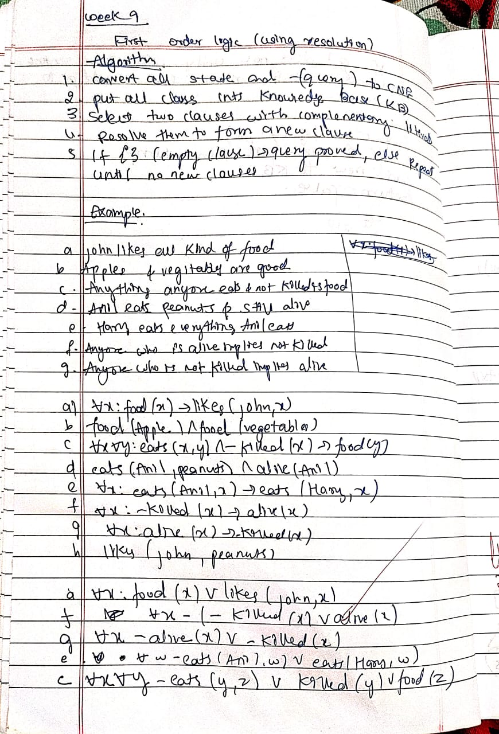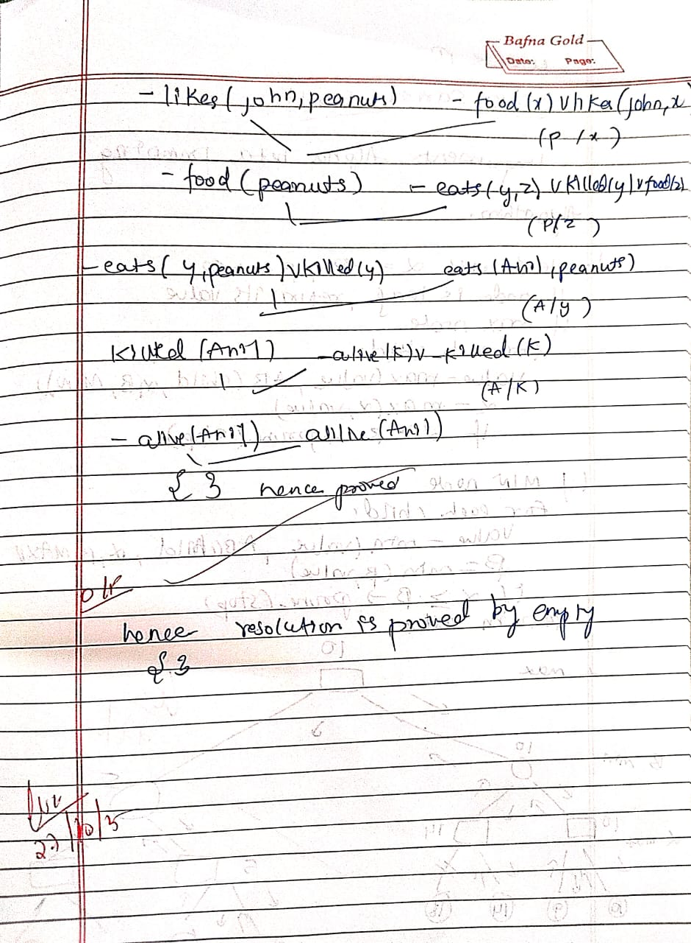
print("Sinchana")
print("1BM23CS329")
from typing import List, Set

def substitute(clause, var, value):
"""Substitute a variable with a value in a clause."""
return {literal.replace(var, value) for literal in clause}

def unify(literal1: str, literal2: str):
"""Check if two literals can be unified and return substitution if possible."""
if literal1.startswith("~"):
l1_pred = literal1[1:]
neg1 = True
else:
l1_pred = literal1
neg1 = False

if literal2.startswith("~"):
l2_pred = literal2[1:]
neg2 = True
else:
l2_pred = literal2
neg2 = False

# Must have same predicate name
if l1_pred.split("(")[0] != l2_pred.split("(")[0]:
return None

# Must be opposite signs for resolution
if neg1 == neg2:
return None

args1 = l1_pred[l1_pred.find("(")+1:-1].split(",")
args2 = l2_pred[l2_pred.find("(")+1:-1].split(",")

if len(args1) != len(args2):
return None

substitution = {}
for a1, a2 in zip(args1, args2):
a1, a2 = a1.strip(), a2.strip()
# Variable (lowercase) can unify with constant (uppercase)
if a1[0].islower() and not a2[0].islower():
substitution[a1] = a2
elif a2[0].islower() and not a1[0].islower():
substitution[a2] = a1
elif a1 != a2:
return None
return substitution

def resolve(clause1: Set[str], clause2: Set[str]):
"""Resolve two clauses."""
resolvents = []
for lit1 in clause1:
for lit2 in clause2:
substitution = unify(lit1, lit2)
if substitution:
(var, val) = list(substitution.items())[0]
new_clause1 = substitute(clause1 - {lit1}, var, val)
new_clause2 = substitute(clause2 - {lit2}, var, val)
new_clause = new_clause1.union(new_clause2)
resolvents.append((lit1, lit2, substitution, new_clause))
return resolvents

def resolution(kb: List[Set[str]], query: Set[str]) -> bool:
"""Resolution algorithm with step-by-step printing."""
clauses = kb + [set(f"~{q}" for q in query)] # Negate query
step = 1
print("\n--- Resolution Steps ---")

while True:
n = len(clauses)
pairs = [(clauses[i], clauses[j]) for i in range(n) for j in range(i + 1, n)]
new = set()

for (ci, cj) in pairs:
resolvents = resolve(ci, cj)
for (lit1, lit2, substitution, result_clause) in resolvents:
print(f"\nStep {step}:")
print(f"Resolving {ci} and {cj}")
print(f" - Unifying {lit1} with {lit2}")
print(f" - Substitution: {substitution}")
print(f" - Resulting clause: {result_clause if result_clause else '{}'}")
step += 1

if not result_clause: # Empty clause => proved
print("\n❗ Contradiction found — query is proven true.")
return True

new.add(frozenset(result_clause))

if new.issubset(set(map(frozenset, clauses))):
print("\nNo new clauses — query cannot be proven.")
return False

for c in new:
if c not in clauses:
clauses.append(set(c))

def main():
print("=== First Order Logic Resolution Prover ===")
n = int(input("Enter number of clauses in the knowledge base: "))

kb = []
print("\nEnter each clause separated by OR (|). Use '~' for NOT.\n")

for i in range(n):
clause_str = input(f"Clause {i+1}: ").replace(" ", "")
literals = set(clause_str.split("|"))
kb.append(literals)

query_str = input("\nEnter query: ").replace(" ", "")
query = {query_str}

print("\n=== Resolution Process ===")
result = resolution(kb, query)

print("\n Final Result:", "Proved " if result else "Not Proved ")

if __name__ == "__main__":

PROGRAM-10
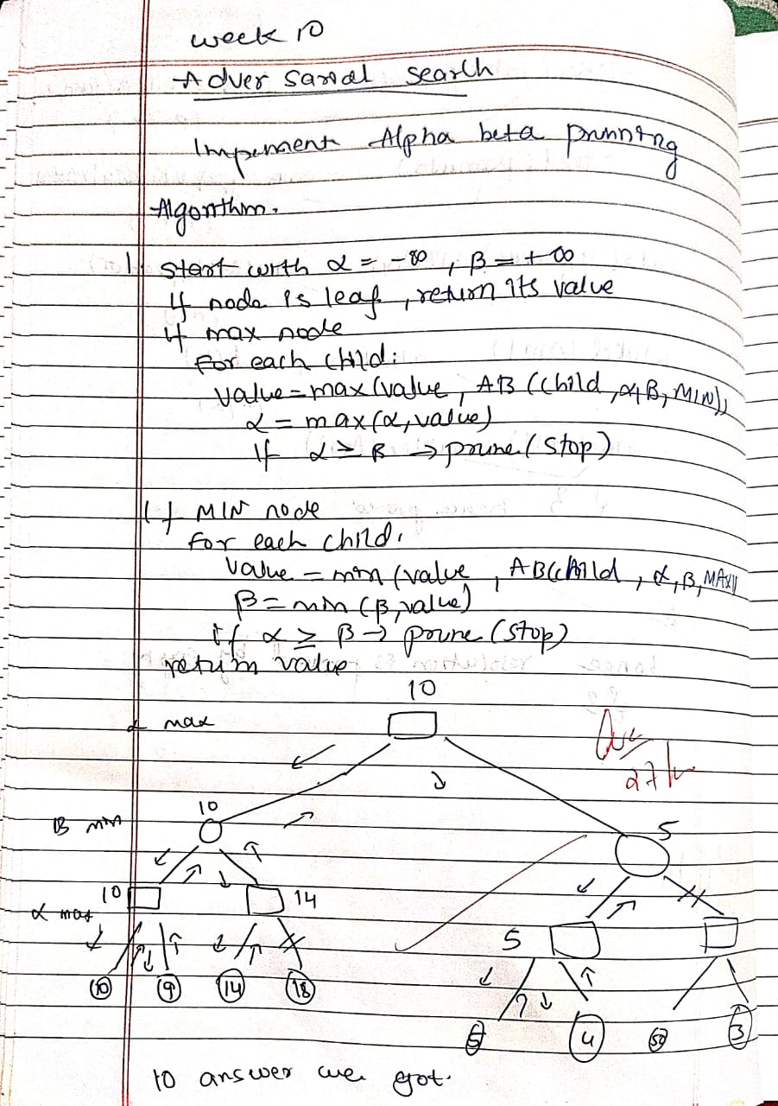

)
print("Sinchana")
print("1BM23CS329")
import math

# --- Alpha-Beta Search ---
def alpha_beta_search(values, max_depth):
"""Alpha-Beta Search using standard pseudocode."""
tree = {} # to store computed node values
pruned = [] # to store pruned branches

def max_value(depth, node_index, alpha, beta):
indent = " " * depth
if depth == max_depth:
print(f"{indent}Leaf Node[{node_index}] = {values[node_index]}")
tree[(depth, node_index)] = values[node_index]
return values[node_index]

print(f"{indent}MAX Node[{node_index}] (α={alpha}, β={beta})")
v = -math.inf
for i in range(2):
child_index = node_index * 2 + i
val = min_value(depth + 1, child_index, alpha, beta)
v = max(v, val)
alpha = max(alpha, v)
print(f"{indent}→ MAX[{node_index}] updated to {v} (α={alpha}, β={beta})")

if v >= beta:
print(f"{indent}⛔ Beta cutoff at Node[{child_index}]")
pruned.append((depth, node_index, "β"))
break

tree[(depth, node_index)] = v
return v

def min_value(depth, node_index, alpha, beta):
indent = " " * depth
if depth == max_depth:
print(f"{indent}Leaf Node[{node_index}] = {values[node_index]}")
tree[(depth, node_index)] = values[node_index]
return values[node_index]

print(f"{indent}MIN Node[{node_index}] (α={alpha}, β={beta})")
v = math.inf
for i in range(2):
child_index = node_index * 2 + i
val = max_value(depth + 1, child_index, alpha, beta)
v = min(v, val)
beta = min(beta, v)
print(f"{indent}→ MIN[{node_index}] updated to {v} (α={alpha}, β={beta})")

if v <= alpha:
print(f"{indent}⛔ Alpha cutoff at Node[{child_index}]")
pruned.append((depth, node_index, "α"))
break

tree[(depth, node_index)] = v
return v

print("\n=== Alpha–Beta Search Steps ===")
best_value = max_value(0, 0, -math.inf, math.inf)
return best_value, tree, pruned

# --- Function to Print Tree in ASCII ---
def print_tree(values, tree, max_depth):
print("\n=== TREE STRUCTURE ===")
index = 0
for depth in range(max_depth + 1):
nodes = 2 ** depth
line = ""
for i in range(nodes):
if (depth, i) in tree:
val = tree[(depth, i)]
else:
val = "—"
line += f"[{val:^5}] "
print(" " * (max_depth - depth) + line)
print()

# --- Main Program ---
def main():
print("=== Alpha–Beta Search Algorithm (Text Tree Output) ===")
max_depth = int(input("Enter maximum depth of tree (e.g., 3): "))
num_leaves = 2 ** max_depth

print(f"\nEnter {num_leaves} leaf node values (space-separated):")
values = list(map(int, input().split()))

if len(values) != num_leaves:
print(f"Error: Expected {num_leaves} values for a complete binary tree.")
return

best_value, tree, pruned = alpha_beta_search(values, max_depth)

print_tree(values, tree, max_depth)

print("=== RESULTS ===")
print(f"Optimal root node value: {best_value}")
if pruned:
print("Pruned branches:")
for p in pruned:
print(f" Node[{p[1]}] at depth {p[0]} ({p[2]} cutoff)")
else:
print("No pruning occurred.")

if __name__ == "__main__":
main()

